AI SEO BLOG & CONTENT CLUSTER GENERATOR
Apex Fitness – Where Goals Become Results
Submitted By
Challa Pradeep
Internship
Future Interns – Prompt Engineering Internship
Date
June 2026

ACKNOWLEDGEMENT
I would like to express my sincere gratitude to Future Interns for providing me with the opportunity to work on this project. This task helped me understand how Prompt Engineering and Artificial Intelligence can be used to generate SEO-optimized content for businesses.
The project enhanced my knowledge of content marketing, keyword optimization, local SEO, content clustering, and AI-powered content generation. I am thankful for the guidance and learning experience that contributed to the successful completion of this project.

ABSTRACT
Apex Fitness is a modern fitness centre located in Delhi that offers personal training, weight loss programs, strength training, yoga, and Zumba classes.
The purpose of this project is to develop an AI-powered SEO Content Cluster Generator using Prompt Engineering techniques. The generated content focuses on improving search engine visibility, increasing website traffic, and helping potential customers discover fitness-related information.
The project includes content clusters, SEO blog topics, internal linking strategies, FAQ content, and local SEO implementation designed specifically for Apex Fitness.

INTRODUCTION
Search Engine Optimization (SEO) plays a crucial role in helping businesses improve their online presence and attract potential customers.
Fitness businesses face intense competition in the digital market, making it essential to create valuable and optimized content that ranks well in search engines.
This project demonstrates how AI and Prompt Engineering can be used to generate high-quality SEO content that addresses user search intent while supporting business growth.

PROBLEM STATEMENT
Many fitness businesses struggle to consistently create high-quality content that ranks well on search engines.
Challenges include:
- Identifying relevant keywords
- Creating engaging blog content
- Maintaining consistency
- Developing content clusters
- Improving local search visibility
AI-powered prompt engineering provides an effective solution by automating content generation while maintaining quality and relevance.

OBJECTIVES
The objectives of this project are:
- To generate SEO-friendly blog content.
- To create a structured content cluster strategy.
- To improve website visibility through local SEO.
- To address customer search queries through FAQ content.
- To demonstrate prompt engineering techniques for content marketing.
- To improve organic website traffic.
- To support customer acquisition through educational content.

BUSINESS OVERVIEW
Business Name
Apex Fitness – Where Goals Become Results
Industry
Fitness and Health
Location
Delhi, India
Services Offered
- Personal Training
- Weight Loss Programs
- Strength Training

TARGET AUDIENCE
Students
Individuals seeking affordable and effective fitness solutions.
Men
Customers interested in strength training, muscle building, and overall fitness.
Women
Customers seeking weight management, fitness training, yoga, and personalized guidance.
Fitness Enthusiasts
Individuals looking to improve their health and physical performance.

UNIQUE SELLING POINTS
Apex Fitness differentiates itself through:
- Certified Trainers
- Modern Equipment
- Affordable Membership Plans
- Personalized Diet Plans
- Women Trainers for Female Members
These features help create a supportive and results-driven fitness environment.

PROMPT ENGINEERING APPROACH
The prompts were structured using the following components:
Business Context
The prompt included:
- Gym Name
- Location
- Services
- Target Audience
- Business Goals
SEO Requirements
The AI was instructed to:
- Generate keyword-focused content
- Create structured headings
- Follow SEO best practices
- Support local SEO
Content Goals
The generated content focuses on:
- User search intent
- Educational value
- Website traffic generation
- Lead generation opportunities
CONTENT CLUSTER STRATEGY
Pillar Topic
Complete Guide to Weight Loss and Muscle Building at Apex Fitness, Delhi
This serves as the central topic connecting all supporting blog articles

Supporting Blog Topics
Blog 1
Best Weight Loss Exercises for Beginners
Blog 2
How to Build Muscle Effectively with Strength Training
Blog 3
Role of Nutrition in Muscle Growth and Fat Loss
Blog 4
Benefits of Personal Training for Faster Results
Blog 5
Yoga for Recovery and Flexibility
Blog 6
Zumba for Weight Loss: Does It Really Work?
Blog 7
How to Choose the Right Gym in Delhi
Blog 8
Common Fitness Mistakes to Avoid
Blog 9
Importance of Certified Trainers
Blog 10
Beginner's Guide to Strength Training

INTERNAL LINKING STRATEGY
The content cluster follows a hub-and-spoke model.
The pillar page links to all supporting articles.
Each supporting article links back to the pillar page and related articles.
Benefits include:
- Improved SEO performance
- Better website navigation
- Increased user engagement
- Stronger topical authority

LOCAL SEO STRATEGY
The content was optimized for local search terms such as:
- Best Gym in Delhi
- Weight Loss Programs in Delhi
- Personal Trainers in Delhi
- Strength Training Gym in Delhi
- Affordable Fitness Centre in Delhi
Local SEO improves visibility among customers searching for nearby fitness services.

FAQ CONTENT
The FAQ section addresses common customer questions regarding:
- Membership Plans
- Gym Timings
- Personal Trainers
- Women Trainers
- Diet Consultation
- Weight Loss Programs
- Trial Sessions
- Student Discounts
- Facilities and Equipment
The FAQ content improves both user experience and search engine visibility.

BENEFITS OF THE PROJECT
Customer Benefits
- Easy access to fitness information
- Better understanding of gym services
- Guidance on fitness and nutrition
- Improved decision-making
Business Benefits
- Increased organic traffic
- Improved search engine rankings
- Better lead generation
- Enhanced online presence
- Increased customer engagement

FINAL OUTCOME
The project successfully demonstrates how Prompt Engineering and AI can be used to generate SEO-optimized content for fitness businesses.
The generated content structure includes blog topics, content clusters, internal linking strategies, FAQ content, and local SEO implementation designed to improve Apex Fitness's digital presence.

SCREENSHOTS
The following figures showcase the AI-generated SEO content assets developed for Apex Fitness.
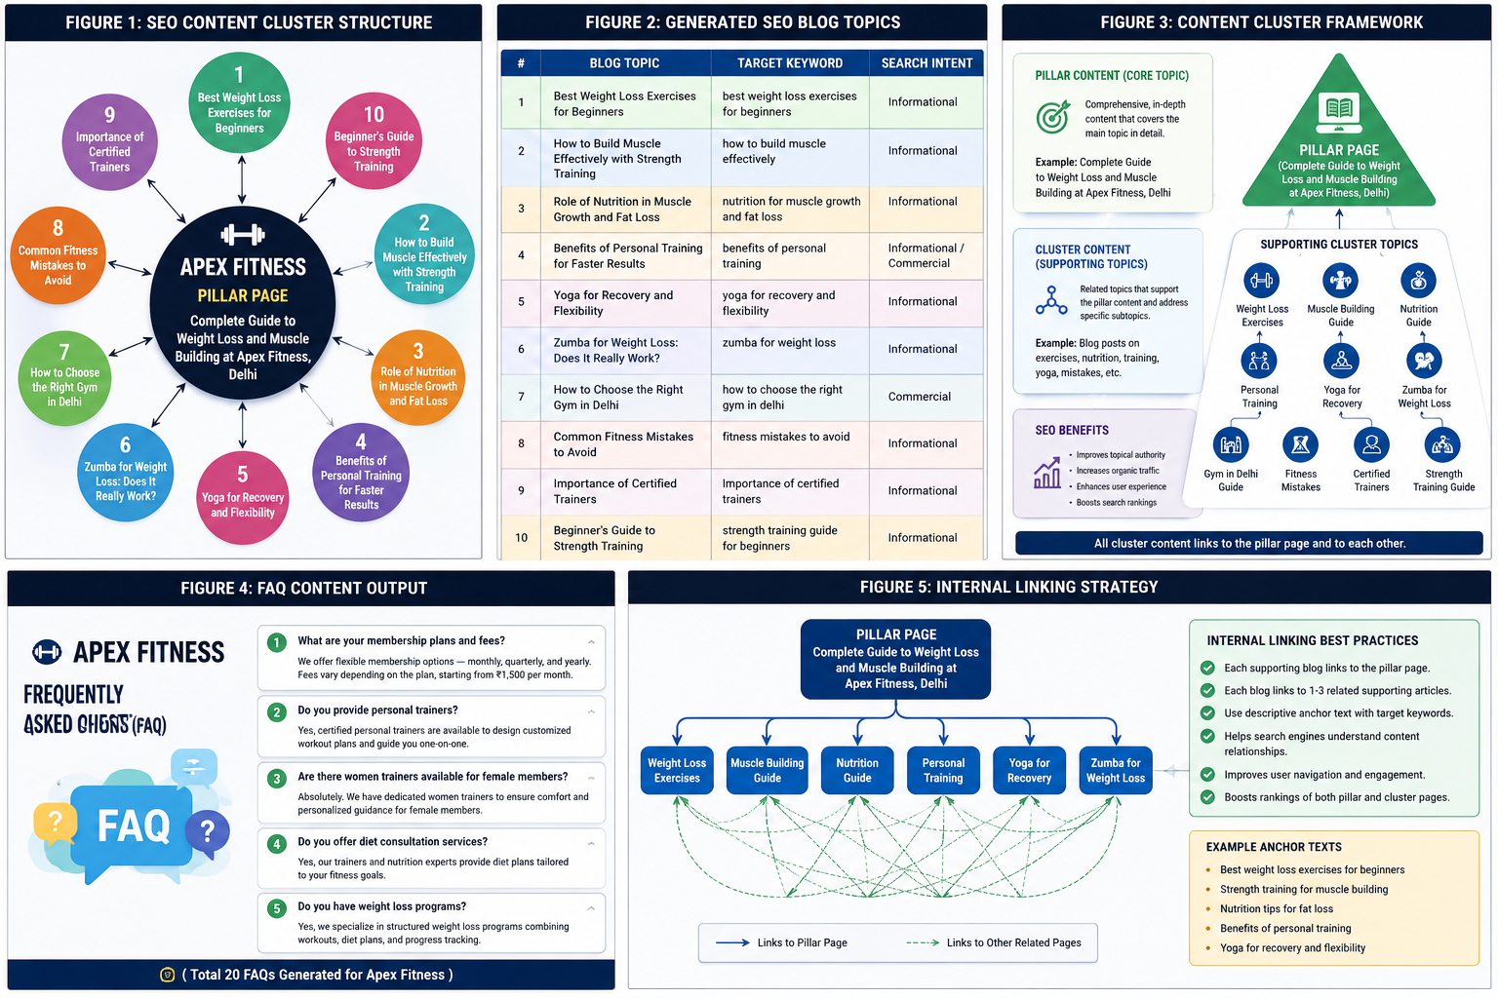

CONCLUSION
This project demonstrates the effective use of Prompt Engineering in SEO content creation and digital marketing.
By combining AI-generated content with SEO best practices, Apex Fitness can improve its online visibility, attract potential customers, and establish authority in the fitness industry.
The project highlights how structured prompts can automate content generation while maintaining quality, relevance, and business value.

REFERENCES
- ChatGPT – AI Content Generation
- SEO Content Marketing Principles
- Local SEO Best Practices
- Content Cluster Strategy
- Fitness Industry Digital Marketing Techniques

